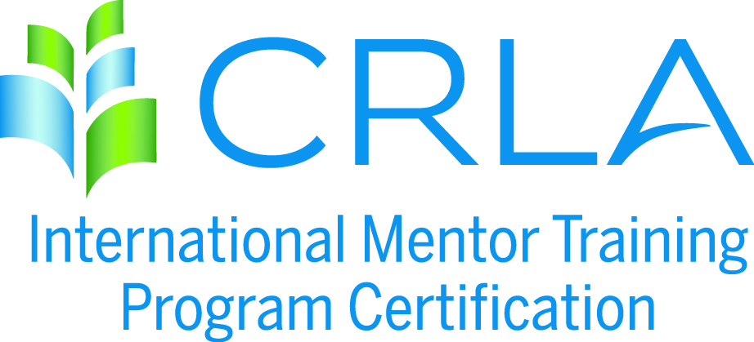
APPLICATION INSTRUCTIONS
Please complete an application for each program to be certified. Refer to Certification Requirements available at crla.net under the Certifications / IMTPC menu for a complete listing of all the LEVEL 1, 2, and 3 requirements.

Step 1: Complete the attached application

Step 2: Attach the necessary documentation. The "necessary documentation" called for under each criteria consists of patterns of evidence of the what, how, and when of the training program. It could/should include any or all of the following that can help the CRLA Mentor Certification Committee verify your program(s): course syllabi, titles of textbooks used, flyers/posters/memos, sample worksheets, handouts, worksheets, training agendas, etc.

Step 3: Please provide a program narrative, one to two pages, explaining how your mentor training program(s) fulfills the requirements of the level(s) requested. The purpose of this overview is to provide the committee members with the appropriate background information necessary to certify your program. This overview should provide the following information: program history, program objectives, reporting lines, sources of funding, services and students served, program location and facility, training guidelines, and training components.
Step 4: All sources must be cited in a comprehensive REFERENCE form (APA format).
- Effective July 1, 2009, Compliance with federal copyright law is expected of all CRLA members and IMTPC programs. It is our legal and ethical responsibility to give authorship credit for all materials we use in the classroom and for tutor and mentor training. Additionally, it is our legal and ethical responsibility to purchase (or have students purchase) copyrighted materials. IMTPC programs found to be in violation of copyright law will lose their certification.
Step 5: Upload all application materials to www.dropbox.com and “share” the folder with the IMTPC Coordinator, Michael Saenz (michael.saenz@utdallas.edu) .
Step 6: Complete the IMTPC Self-Service Invoice form and submit payment.

IMTPC Use Only:
Date Application Rec’d: ____________
Date Fee Rec’d: ___________________
Reviewers: _______________________

APPLICATION FOR PROGRAM CERTIFICATION

INSTITUTION: _________________________________________________________

PROGRAM TO BE CERTIFIED: ___________________________________________

PROGRAM WEBSITE: __________________________________________________

CERTIFICATION LEVELS REQUESTED (please check appropriate box/boxes):

Regular/Level 1 _______
Advanced/Level 2 _______
Master/Level 3 _______

PROGRAM LIAISON/CONTACT PERSON: __________________________________

TITLE: _______________________________________________________________

ADDRESS: ____________________________________________________________

CITY: ___________________________________ STATE: ________ ZIP: __________

COUNTRY: ________ PHONE: ______________ EMAIL: _______________________

SECONDARY CONTACT NAME: __________________________________________

SECONDARY CONTACT EMAIL: __________________________________________

Where did you first hear about IMTPC? ______________________________________

Do you allow IMTPC to use your application packet as a “sample application” or a “model program”? ___ YES ___NO
(Permission allows IMTPC to share your full packet contents with colleagues and/or post to IMTPC website.)

APPLICATION FEE: Please review step 6 for payment process. No POs will be accepted. Federal ID #95-3177158. Level 1 = $150; Levels 1 & 2 = $250; All 3 Levels = $350

CRLA’s Copyright Policy:
“Compliance with federal copyright law is expected of all CRLA-IMTPC programs. It is our legal and ethical responsibility to give authorship credit for all materials we use in the classroom, or tutor, or mentor training. Additionally, it is our legal and ethical responsibility to purchase, or to have students purchase, any copyrighted materials used in training. Programs found to be in violation of copyright law will lose their CLRA-IMTPC certification.”

VERIFICATION OF PROGRAM COMPLIANCE & ACCURACY

By signing below, I verify that the information submitted in this application and supporting materials is accurately representing my campus program. I also agree to follow CRLA’s Copyright Policy throughout this certification period.

Name : ______________________________ _____/_____/______
As this program’s primary contact, your required signature can be submitted as: a .jpg; an e-sig (e-signature), or just typed in.

MENTOR SELECTION CRITERIA

- Explain how your mentors are selected (1,2, and 3 required; 4 is optional)

Level 1 ___:
Level 2 ___ Met at Level 1:
Level 3 ___ Met at Level 1:

- Extent of compliance; Check all that apply. This selection procedure:

Level 1 _____ | Meets Criteria _____ | Exceeds Criteria _____
Level 2 _____ | Meets Criteria _____ | Exceeds Criteria _____
Level 3 _____ | Meets Criteria _____ | Exceeds Criteria _____

- The necessary documentation to verify the above is attached and labeled accordingly.

AMOUNT/DURATION OF MENTOR TRAINING

- List the number of hours involved in your mentor training:

Level 1: _____ Hours | Level 2: _____ Hours | Level 3: _____ Hours

- Extent of Compliance. Check all that apply.

Level 1 Option 1: Tutor Certification Plus 5 Hours | _____ Met | _____ Exceeded
Level 1 Option 2: 15 Total Required Hours | _____ Met | _____ Exceeded
Level 2: Level 1 Certification plus 10 Hours (25 total) | _____ Met | _____ Exceeded
Level 3: Level 2 Certification plus 10 Hours (35 total) | _____ Met | _____ Exceeded
- Documentation that will verify the fulfillment of this requirement is attached and labeled accordingly.

MODES OF MENTOR TRAINING

- List the facilitation modes and format you use for your training:

Level 1:
Level 2:
Level 3:

- Extent of compliance; Check all that apply.
Level 1: Classroom/Workshop Plus Any Two Others | _____ Met | _____ Exceeded
Level 2: Classroom/Workshop Plus Any Two Others | _____ Met | _____ Exceeded
Level 3: Classroom/Workshop Plus Any Two Others | _____ Met | _____ Exceeded

- The necessary documentation to verify the above is attached and labeled accordingly.

AREAS/TOPICS TO BE COVERED IN MENTOR TRAINING

- List which topics you cover in your training:

Level 1:
Level 2:
Level 3:

- Extent of Compliance; Check all that apply.
Level 1: 8 Hours Minimum | _____ Met | _____ Exceeded
Level 2: Review of Level 1 plus at least 4 additional topics | _____ Met | _____ Exceeded
Level 3: Review of Levels 1 & 2 plus at least 4 additional topics | _____ Met | _____ Exceeded

- The necessary documentation to verify the above is attached and labeled accordingly.

MENTOR TRAINING SUMMARY CHART
- Please complete the following chart, outlining for reviewers how and when each IMTPC training topic is addressed with your peer mentor program.

IMTPC Required Topic | Program’s  Session Title | Time Spent on Training | Mode of Training | References to Documented Evidence of Completion
 |  | TOTAL TRAINING HOURS:

REQUIRED MENTORING EXPERIENCE

- Explain how you keep track of your mentors' actual mentoring experience.

Level 1:
Level 2:
Level 3:

- Extent of compliance; Check all that apply.
Level 1 _____ | Meets Criteria _____ | Exceeds Criteria _____
Level 2 _____ | Meets Criteria _____ | Exceeds Criteria _____
Level 3 _____ | Meets Criteria _____ | Exceeds Criteria _____

- The necessary documentation to verify the above is attached and labeled accordingly.

MENTOR EVALUATION CRITERIA

- How are your mentors evaluated? Check all that apply.
Level 1: | ____ an evaluation is in place
Level 1: | ____ it occurs at least annually
Level 1: | ____ it includes an evaluation of mentors by mentees
Level 1: | ____ results of Evaluation are shared with mentors
Level 2: | ____ Met at Level 1
Level 3: | ____ Met at Level 1

- Extent of compliance; Check all that apply.
Level 1: | ____ Meets criteria
Level 2: | ____ Met at Level 1
Level 3: | ____ Met at Level 1
Level 3: | ____ Exceeds criteria
- The necessary documentation to verify the above is attached and labeled accordingly.

