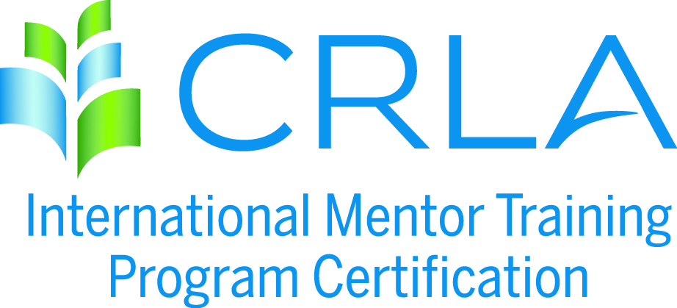
APPLICATION INSTRUCTIONS
Please complete an application for each program to be certified. Refer to Certification Requirements available at crla.net under the Certifications / IMTPC menu for a complete listing of all the LEVEL 1, 2, and 3 requirements.

Step 1: Complete the attached application

Step 2: Attach the necessary documentation. The "necessary documentation" called for under each criteria consists of patterns of evidence of the what, how, and when of the training program. It could/should include any or all of the following that can help the CRLA Mentor Certification Committee verify your program(s): course syllabi, titles of textbooks used, flyers/posters/memos, sample worksheets, handouts, worksheets, training agendas, etc.

Step 3: Please provide a program narrative, one to two pages, explaining how your mentor training program(s) fulfills the requirements of the level(s) requested. The purpose of this overview is to provide the committee members with the appropriate background information necessary to certify your program. This overview should provide the following information: program history, program objectives, reporting lines, sources of funding, services and students served, program location and facility, training guidelines, and training components.
Step 4: All sources must be cited in a comprehensive REFERENCE form (APA format).
- Effective July 1, 2009, Compliance with federal copyright law is expected of all CRLA members and IMTPC programs. It is our legal and ethical responsibility to give authorship credit for all materials we use in the classroom and for tutor and mentor training. Additionally, it is our legal and ethical responsibility to purchase (or have students purchase) copyrighted materials. IMTPC programs found to be in violation of copyright law will lose their certification.
Step 5: Upload all application materials to www.dropbox.com and “share” the folder with the IMTPC Coordinator, Michael Saenz (michael.saenz@utdallas.edu).
Step 6: Complete the IMTPC Self-Service Invoice form and submit payment.

THREE YEAR CERTIFICATION RENEWAL

INSTITUTION: ________________________________________________________________
PROGRAM TO BE CERTIFIED: __________________________________________________
PROGRAM LIAISON/CONTACT PERSON: ________________________________________
ADDRESS: ____________________________________________________________________
CITY: ______________________________________ STATE: ___________ ZIP: ___________
PHONE: _________________________________ FAX: ________________________________
EMAIL: _______________________________________________________________________
NUMBER OF MENTOR CERTIFICATES GRANTED: ___________

RECERTIFICATION LEVELS REQUESTED (please check appropriate box/boxes):
Regular/Level 1_______ Advanced/Level 2 _______ Master/Level 3 _______
PROGRAM NARRATIVE: Please write a program narrative including any projected changes in your mentor training program (submit documentation of these changes to the IMTPC coordinator), concerns/issues that arose in the administration of the certification requirements, and benefits of certification to your institution.

*Effective July 1, 2009, Compliance with federal copyright law is expected of all CRLA members and IMPC programs. It is our legal and ethical responsibility to give authorship credit for all materials we use in the classroom and for tutor and mentor training. Additionally, it is our legal and ethical responsibility to purchase (or have students purchase) copyrighted materials. IMPC programs found to be in violation of copyright law will lose their certification.
By signing below, I verify that the information submitted in this application and supporting materials is accurately representing my campus program. I also agree to follow CRLA’s Copyright Policy throughout this certification period.
Name : ______________________________ _____/_____/______

