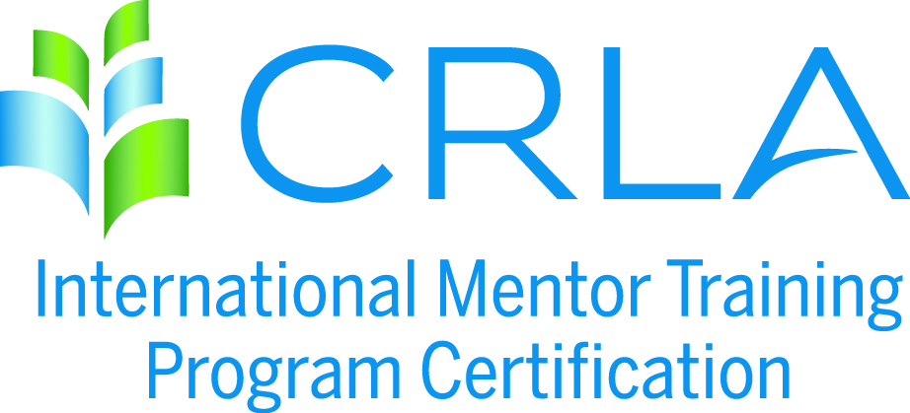
APPLICATION INSTRUCTIONS
Please complete an application for each program to be certified. Refer to Certification Requirements available at crla.net under the Certifications / IMTPC menu for a complete listing of all the LEVEL 1, 2, and 3 requirements.
Step 1: Complete the attached application
Step 2: Attach the necessary documentation. The "necessary documentation" called for under each criteria consists of patterns of evidence of the what, how, and when of the training program. It could/should include any or all of the following that can help the CRLA Mentor Certification Committee verify your program(s): course syllabi, titles of textbooks used, flyers/posters/memos, sample worksheets, handouts, worksheets, training agendas, etc.
Step 3: Please provide a program narrative, one to two pages, explaining how your mentor training program(s) fulfills the requirements of the level(s) requested. The purpose of this overview is to provide the committee members with the appropriate background information necessary to certify your program. This overview should provide the following information: program history, program objectives, reporting lines, sources of funding, services and students served, program location and facility, training guidelines, and training components.
Step 4: All sources must be cited in a comprehensive REFERENCE form (APA format).
- Effective July 1, 2009, Compliance with federal copyright law is expected of all CRLA members and IMTPC programs. It is our legal and ethical responsibility to give authorship credit for all materials we use in the classroom and for tutor and mentor training. Additionally, it is our legal and ethical responsibility to purchase (or have students purchase) copyrighted materials. IMTPC programs found to be in violation of copyright law will lose their certification.
Step 5: Upload all application materials to www.dropbox.com and “share” the folder with the IMTPC Coordinator, Michael Saenz (michael.saenz@utdallas.edu) .
Step 6: Complete the IMTPC Self-Service Invoice form and submit payment, by visiting our website: www.crla.net.

FIVE YEAR CERTIFICATION RENEWAL PACKET
INSTITUTION: _________________________________________________________
PROGRAM TO BE CERTIFIED: ___________________________________________
PROGRAM WEBSITE: __________________________________________________
CERTIFICATION LEVELS REQUESTED (please check appropriate box/boxes):
Regular/Level 1 _______
Advanced/Level 2 _______
Master/Level 3 _______
PROGRAM LIAISON/CONTACT PERSON: __________________________________
TITLE: _______________________________________________________________
ADDRESS: ____________________________________________________________
CITY: ___________________________________ STATE: ________ ZIP: __________
COUNTRY: ________ PHONE: ______________ EMAIL: _______________________
SECONDARY CONTACT NAME: __________________________________________
SECONDARY CONTACT EMAIL: __________________________________________
Where did you first hear about IMTPC? ______________________________________
Do you allow IMTPC to use your application packet as a “sample application” or a “model program”? ___ YES ___NO
(Permission allows IMTPC to share your full packet contents with colleagues and/or post to IMTPC website.)
APPLICATION FEE: Please review step 6 for payment process. No POs will be accepted. Federal ID #95-3177158. Level 1 = $150; Levels 1 & 2 = $250; All 3 Levels = $350
VERIFICATION OF PROGRAM COMPIANCE & ACCURACY

CRLA’s Copyright Policy:
“Compliance with federal copyright law is expected of all CRLA-IMTPC programs. It is our legal and ethical responsibility to give authorship credit for all materials we use in the classroom, or tutor, or mentor training. Additionally, it is our legal and ethical responsibility to purchase, or to have students purchase, any copyrighted materials used in training. Programs found to be in violation of copyright law will lose their CLRA-IMTPC certification.”
By signing below, I verify that the information submitted in this application and supporting materials is accurately representing my campus program. I also agree to follow CRLA’s Copyright Policy throughout this certification period.
Name : ______________________________ _____/_____/______

OVERVIEW OF THE MENTOR TRAINING PROGRAM TO BE CERTIFIED

Please provide a two-page overview summarizing how your mentor training program fulfills the requirements of the level or levels of certification you are seeking. The purpose of this overview is to provide the Reviewers with the background information necessary to understand your program. This overview should include:
1) Program history
2) Program objectives
3) Reporting lines
4) Sources of funding
5) Services and students served
6) Program location and facility
7) Training guidelines (administration; selection, hours, tracking, evaluation, etc.)
8) How you generally conduct your training. (group size, meeting frequency/length, type of presentation)

VERIFICATION OF MENTOR TRAINING PROGRAM

Please complete an application for each program you want to be certified. For example, if you wish to have a “Mathematics Center Program” certified at Levels 1 & 2, please complete the application for Levels 1 & 2. If you also have a “Writing Center Program” with a different training program that you wish to have certified at Level 1, you must submit a totally separate application, with its own separate fee.
Please refer "CRLA'S REQUIREMENTS FOR CERTIFICATION OF MENTOR PROGRAMS" for a complete list of all LEVEL 1, 2, and 3 requirements for a program to be certified.
The "necessary documentation" required for each criteria consists of patterns of evidence of the what, how, and when of the training program. It should include enough samples and documentation to enable CRLA Reviewers to verify the excellence of your program(s). Examples of documentation include:
- course syllabi, workshop overview, or program description
- titles and ISBN numbers of copyrighted books, videos, DVDs, surveys, and other training materials used
- URLs of web pages or websites
- flyers/posters/memo samples
- worksheet samples
- handout samples
The better the documentation you provide, the easier it will be for the reviewers to certify your program(s); however, brevity is appreciated so condensed but complete documentation is requested. Any complete files you feel should be attached, should be listed in the section above called List of Documents.
A. MENTOR SELECTION CRITERIA
Describe how your mentors are selected (must meet first three criteria). List only for the levels for which you are applying:
Level 1:
___GPA of 3.0 or higher
___Interview with the mentor trainer/supervisor
___Two or more references from faculty, former supervisors, or counselors/advisors
___ Personality type assessment (recommended but optional)
Level 1: Met __ or Exceeded ___
Documentation:

Level 2: Met __ or Exceeded ___
Documentation (not needed if met in Level 1) :

Level 3: Met __ or Exceeded ___
Documentation (not needed if met in Level 1 or Level 2) :
B. MENTOR TRAINING: Amount/Duration
1) List the number of hours involved in your mentor training, 2) whether you have met or exceeded the minimum, and 3) the Documentation you have attached as a file to confirm your compliance (an example might be: Mentor Training Syllabus, pages 2-4). List only for the levels for which you are applying:
Number of Hours for Level 1: ___ (15 hours total is the minimum required)
The requirements of Level 1 are: Met __ or Exceeded ___
Documentation:
Number of Hours for Level 2: ___ (Additional 10 hours; 25 total hours is minimum required)
The requirements of Level 1 are: Met __ or Exceeded ___
Documentation:
Number of Hours for Level 3: ___ (Additional 10 hours; 35 total hours is minimum required)
The requirements of Level 1 are: Met __ or Exceeded ___
Documentation:
C. Mentor Training-Modes
1) List the training modes involved in your mentor training, 2) whether you have met or exceeded the minimum, and 3) the Documentation you have attached as a file to confirm your compliance (an example might be your Mentor Training Syllabus, pages 4-6). List only for the levels for which you are applying:
Level 1:
(classroom/workshop plus any two others are the minimum required)
The requirements of Level 1 are: Met __ or Exceeded ___
Documentation:
Level 2:
(classroom/workshop plus any two others are the minimum required)
The requirements of Level 2 are: Met __ or Exceeded ___
Documentation:
Level 3:
(classroom/workshop plus any two others are the minimum required)
The requirements of Level 1 are: Met __ or Exceeded ___
Documentation:
D. MENTOR TRAINING-Topics to Cover
List which topics you cover in your mentor training, whether you have met or exceeded the minimum, and the Documentation you have attached as a file to confirm your compliance (an example might be your Mentor Training Syllabus, pages 7-8) List only for the levels for which you are applying:

LEVEL 1: TOPICS, MATERIALS, AND DOCUMENTATION SUMMARY CHART
(Applicable ONLY for Level 1) (To add rows to table, tab last field)

Topic | When  Covered | Amount  of time | Methods | Materials Used/ Documentation

The requirements of Level 1 are: Met __ or Exceeded ___
Documentation:

LEVEL 2: TOPICS, MATERIALS, AND DOCUMENTATION SUMMARY CHART
(Applicable ONLY for Level 2) (To add rows to table, tab last field)

Topic | When  Covered | Amount  of time | Methods | Materials Used/ Documentation
The requirements of Level 2 are: Met ___ or Exceeded ___
Documentation:
LEVEL 3: TOPICS, MATERIALS, AND DOCUMENTATION SUMMARY CHART
(Applicable ONLY for Level 3) (To add rows to table, tab last field)

Topic | When  Covered | Amount  of time | Methods | Materials Used/ Documentation
The requirements of Level 3 are: Met ___ or Exceeded ___
(a review of Levels 1 and 2, the 3, plus any other elective topics to total 10 hours of additional training beyond levels 1 & 2)
Documentation:
E. REQUIRED MENTORING EXPERIENCE
1) Describe how you keep track of your mentors’ actual mentoring experience, 2) whether you have met or exceeded the minimum, and 3) the Documentation you have attached as a file to confirm your compliance (an example might be your Mentor Time logs) List only for the levels for which you are applying:

Level 1:
(Option 1: 25 tutoring hours & 25 mentoring hours; Option 2: 50 mentoring hours)
Level 1: Met __ or Exceeded ___
Documentation:

Level 2:
(a total of 75 hours of mentoring experience is the minimum) Level 2: Met ___ or Exceeded ___
Documentation:

Level 3:
(a total of 100 hours of mentoring experience is the minimum) Level 3: Met ___ or Exceeded ___
Documentation:
F. MENTOR EVALUTION CRITERIA
How are your mentors evaluated? Check all that apply. List only for the levels for which you are applying:
Level 1:
___An evaluation process is in place
___Evaluation occurs at least annually
___Evaluation process includes mentees’ evaluation of mentors
___Results of the evaluation process are made known to mentors
___ Other ________________________________________
Level 1: Met __ or Exceeded ___
Documentation:
Level 2: Met __ or Exceeded ___
Documentation (not needed if met in Level 1) :

Level 3: Met __ or Exceeded ___
Documentation (not needed if met in Level 1 or Level 2) :

By submitting this application, you as program contact/liaison with CRLA’s International Mentor Training Program Certification agree to continue to follow the guidelines you have submitted in this application.
Once your program is re-certified, CRLA will provide you with a certificate certifying your program for up to five years and will provide you with a CRLA IMTPC certificate template you may use and adapt to include your institution’s information/logos/signatures/colors.

Two to six months before the end of your renewal period, you will be expected to apply for re-certification. Each re-certification granted for this program will be for up to five years. Re-certification is patterned after the initial certification application requirements and documentation, so be sure to archive your initial documents to use as a reference to update with current program information for your re-certifications.

