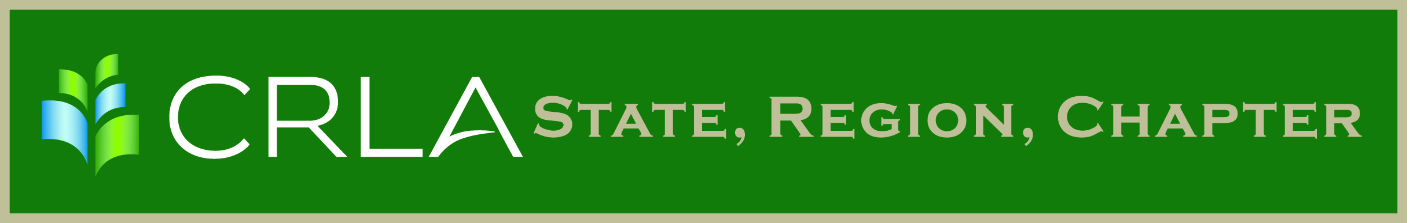

Official Newsletter of the SRC Name Here

Month 2019

Volume No, Issue No

Title 1

Author Info

2019 CRLA Board

President  
Page Keller

[kellerp@cofc.edu](mailto:kellerp@cofc.edu)

President-Elect  
Kathy Stein

[kstein@sulross.edu](mailto:kstein@sulross.edu)

Past President  
Victoria Appatova

[victoria.appatova@uc.edu](mailto:victoria.appatova@uc.edu)

Secretary  
Marissa Loon

[mloon@ju.edu](mailto:mloon@ju.edu)

Treasurer  
Maureen DuPont

[mdupont@csusm.edu](mailto:mdupont@csusm.edu)

Certifications Director  
Roberta Schotka

[r.schotka@crla.net](mailto:r.schotka@crla.net)

Professional Development Director  
Jon Mladic

[Jon.mladic@rasmussen.edu](mailto:Jon.mladic@rasmussen.edu)

Public Relations Director  
Lisa Sharfstein

[lrsharfstein@carlow.edu](mailto:lrsharfstein@carlow.edu)

Publications Director   
Melissa Thomas

[melissathomas@utexas.edu](mailto:melissathomas@utexas.edu)

1

Page 4

Page 6