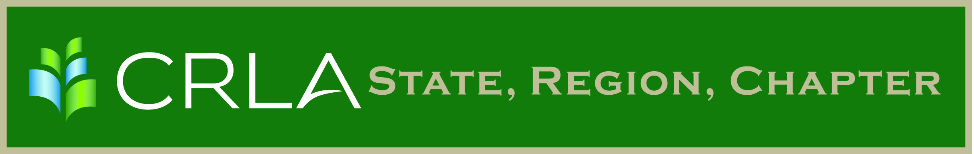

Official Newsletter of the New Mexico Chapter of CRLA

May 2017

Volume No,1 Issue No 1

Save The Date

The New Mexico College Reading and Learning Conference now has an official date. It will be held on Friday, July 21, 2017 at Central New Mexico CC ‘s Westside Campus. The conference will open with check-in and a continental breakfast at 8:30am and include lunch for all registered attendees. The theme for this year is “Soar to New Heights.”

The call for proposal submission begins today and the deadline for proposals is June 10, 2017. The proposal form is attached to this email.

This is an exciting year because Lucy MacDonald, Professor Emeritus from Chemeketa Community College and author of “HowtoStudy.org” will be the keynote speaker at the conference.

Please consider submitting a proposal. Share the best practices from your courses, new trainings that you are doing in your learning assistance centers or any other topic in developmental education that you would like to share with all of us. This conference is for you to network with your colleagues in the state and learn about what is going on in their colleges and institutions.



2016 CRLA Board

President  
Jack Trammell

[jtrammel@rmc.edu](mailto:woodruff@hawaii.edu)

President Elect  
Victoria Appatova

[Victoria.appatova@us.edu](mailto:Victoria.appatova@us.edu)

Past President

Dorothy Briggs

[dabriggs@email.arizona.edu](mailto:dabriggs@email.arizona.edu)

Secretary  
Kathy Stein

[kstein@sulross.edu](mailto:kstein@sulross.edu)

Treasurer  
Maureen DuPont

[mdupont@csusm.edu](mailto:mdupont@csusm.edu)

Certifications Director  
Page Keller

[kellerp@cofc.edu](mailto:kellerp@cofc.edu)

Professional Development Director  
Suzanne McCarthy

[mccarthys@centenarycollege.edu](mailto:mccarthys@centenarycollege.edu)

Public Relations Director  
Marissa Loon

[marissa.loon@nichols.edu](mailto:marissa.loon@nichols.edu)

Publications Director  
Sonya L. Armstrong

[sarmstrong@niu.edu](mailto:sarmstrong@niu.edu)

1

